UBUNTU COMMANDS

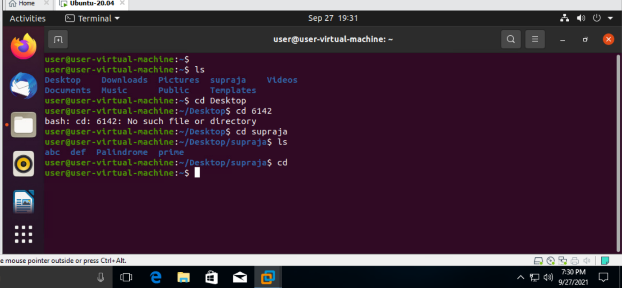

The ls command is used to list files or directories in Linux and other Unix-based operating

systems.

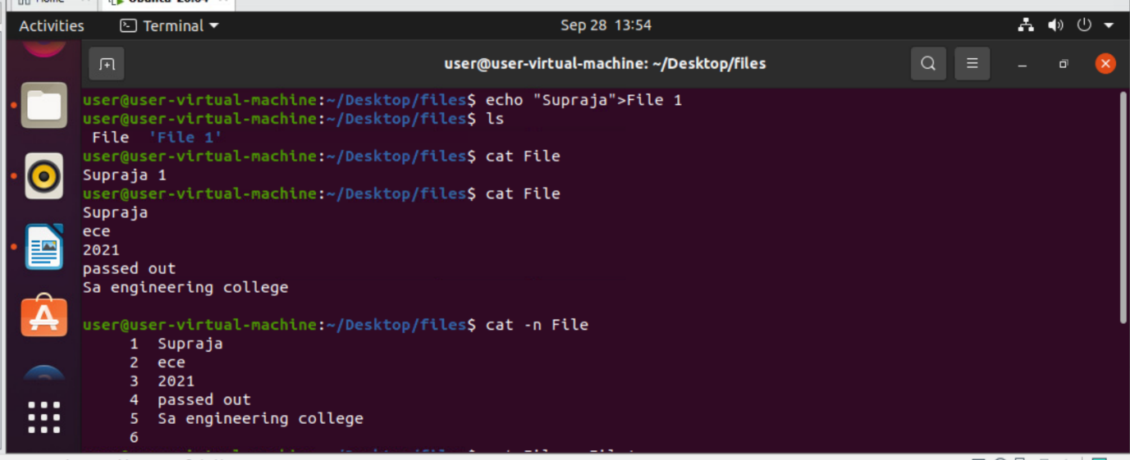

- Cat(concatenate) command is very frequently used in Linux. It reads data from the file and

gives their content as output. It helps us to create, view, concatenate files.

- Cat -n File- It display the content in numerical form.

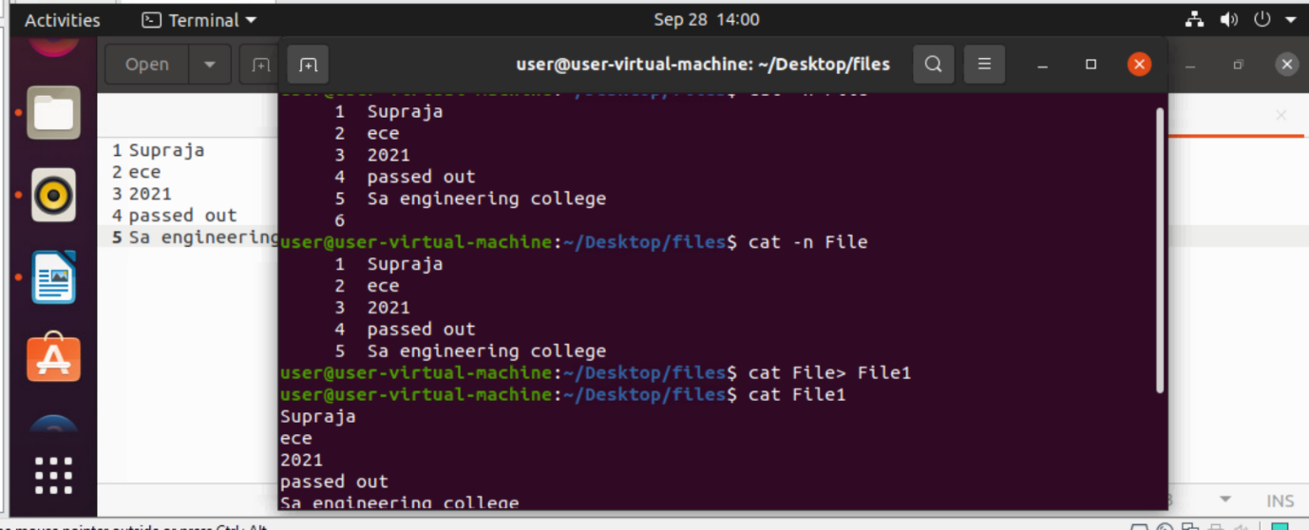

Cat -n File> File1: copy File content in File2

Cat -n File> File1:copy content with numerical.

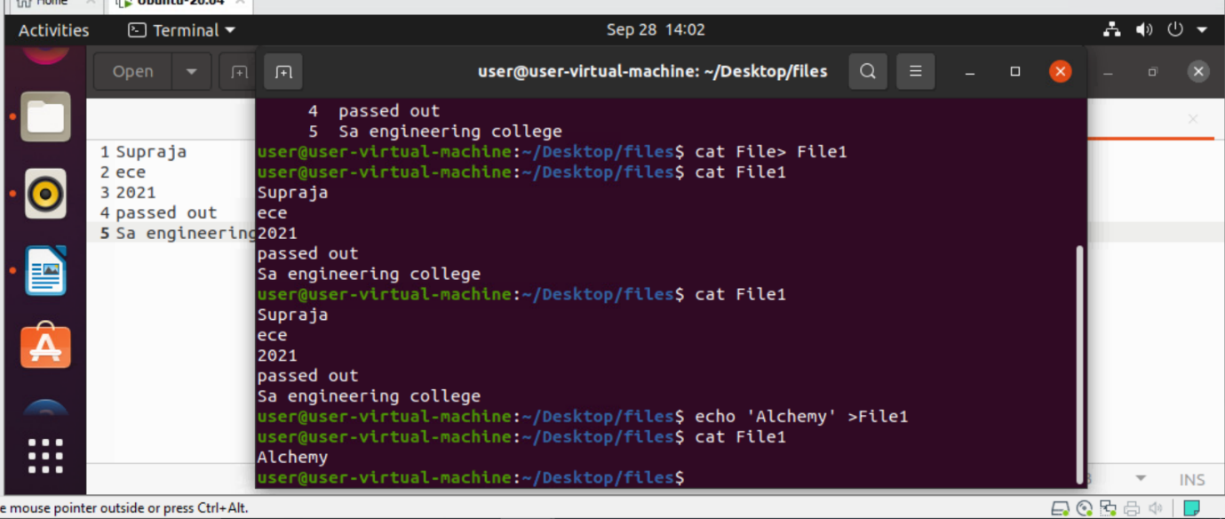

Echo ‘Alchemy’ > File1: appending content in File1

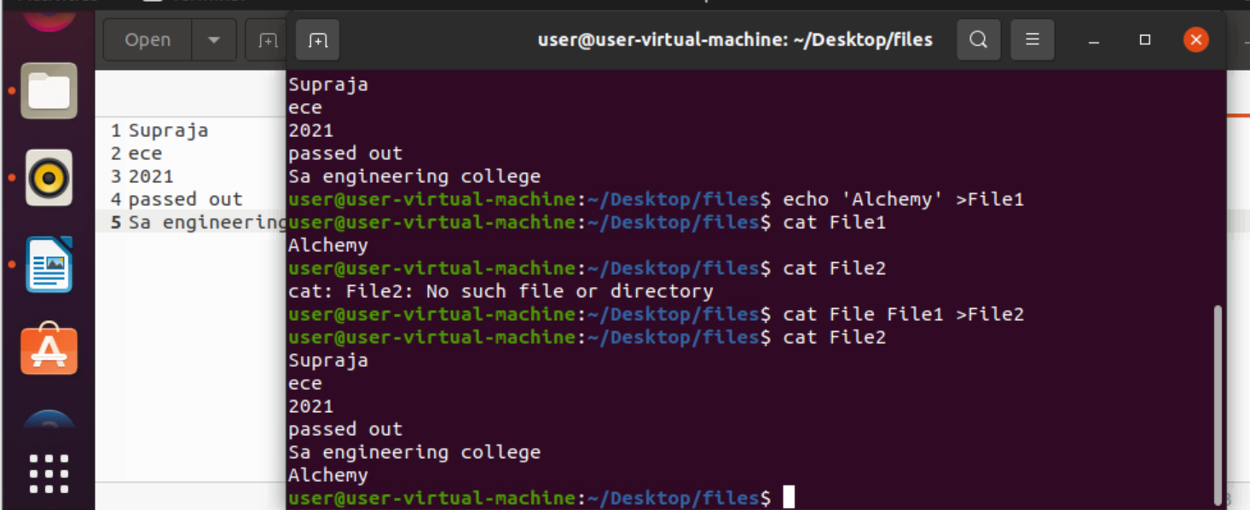

Cat File1 > File2: concatenate two folder and appending in other folder

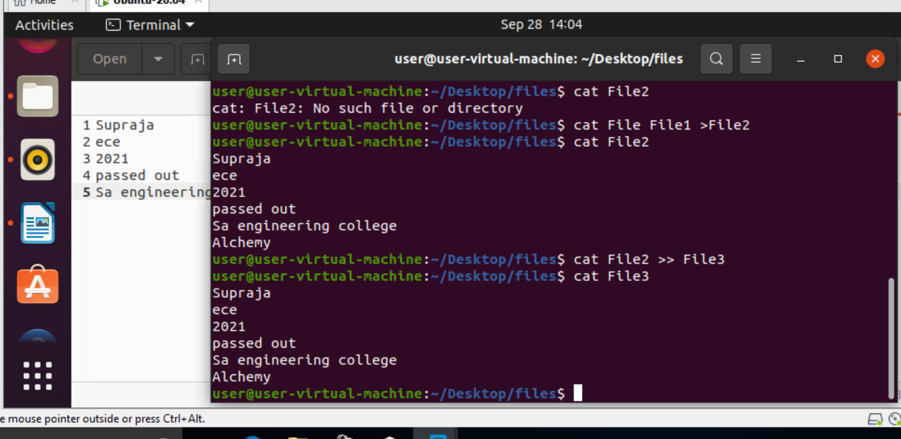

Cat File2 >> File3: Appending all content in File3

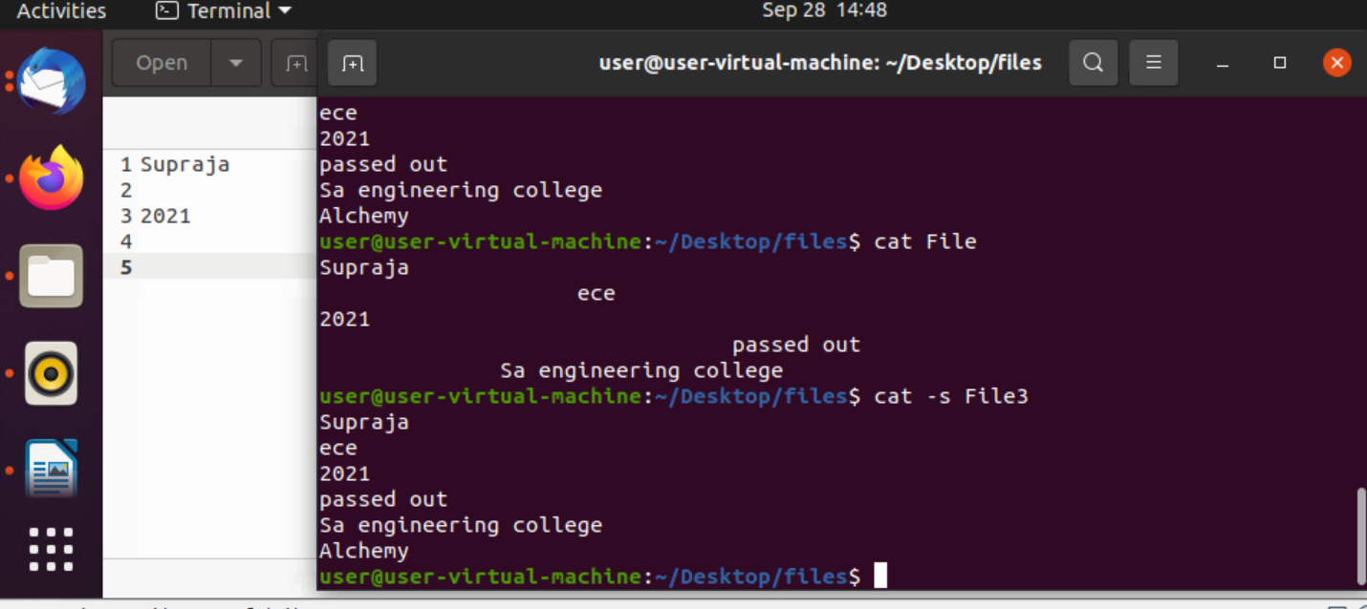

Cat -s File3: Remove all space between content

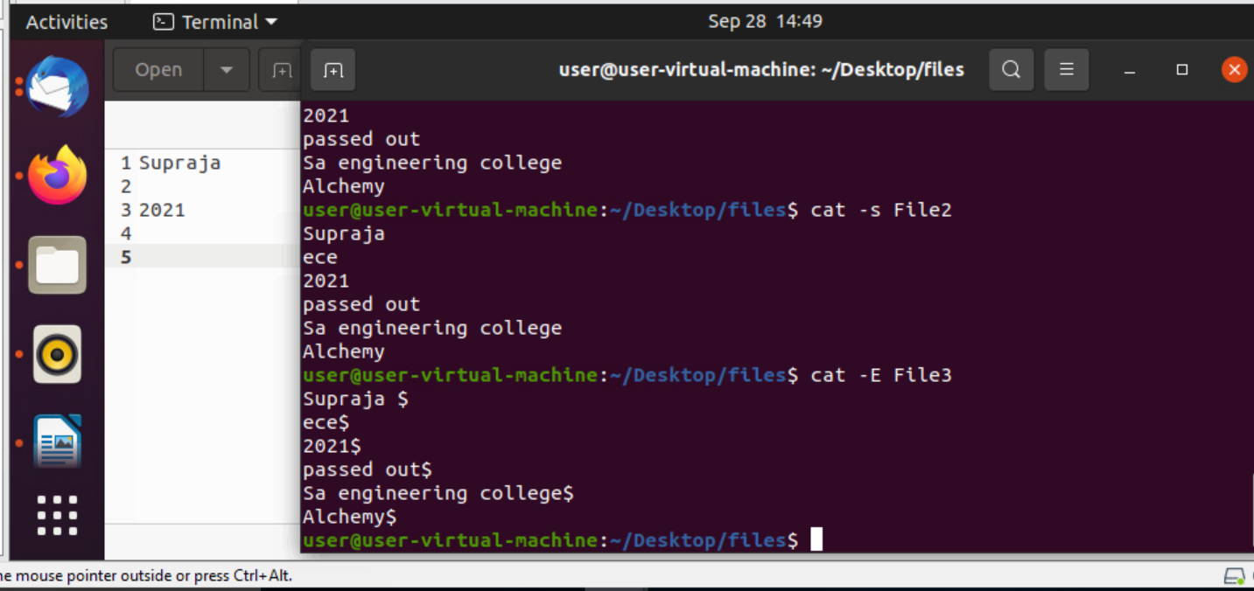

Cat -E File3: It display $ in space.

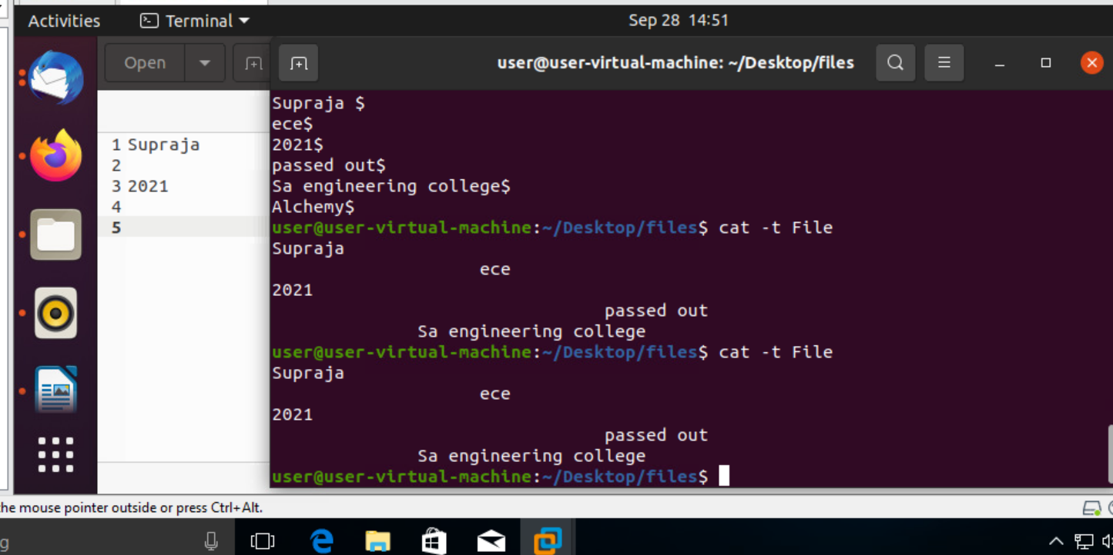

Cat -t File: Use to display tab

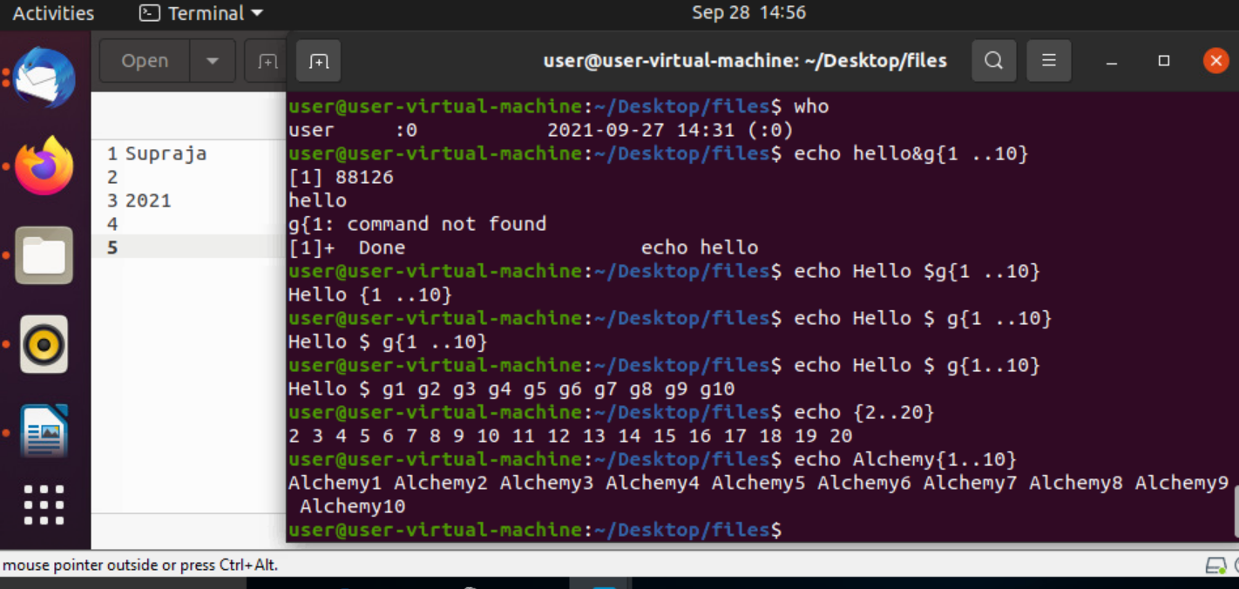

Who: tells which system you currently working.

Whoami: tells which system you currently working

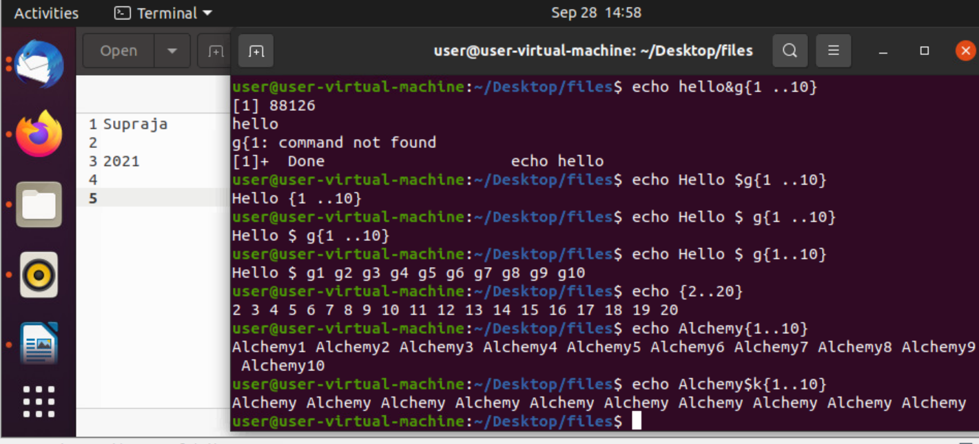

Echo hello&g{1..10}: It display hello 1 to 10.

Echo Hello $ g{1..10}:It will display till 10.

Echo {2..20} : 2 3 4 5 7 8 9……20

Echo Alchemy1..10}: Alchemy1 Alchemy2………. Alchemy10

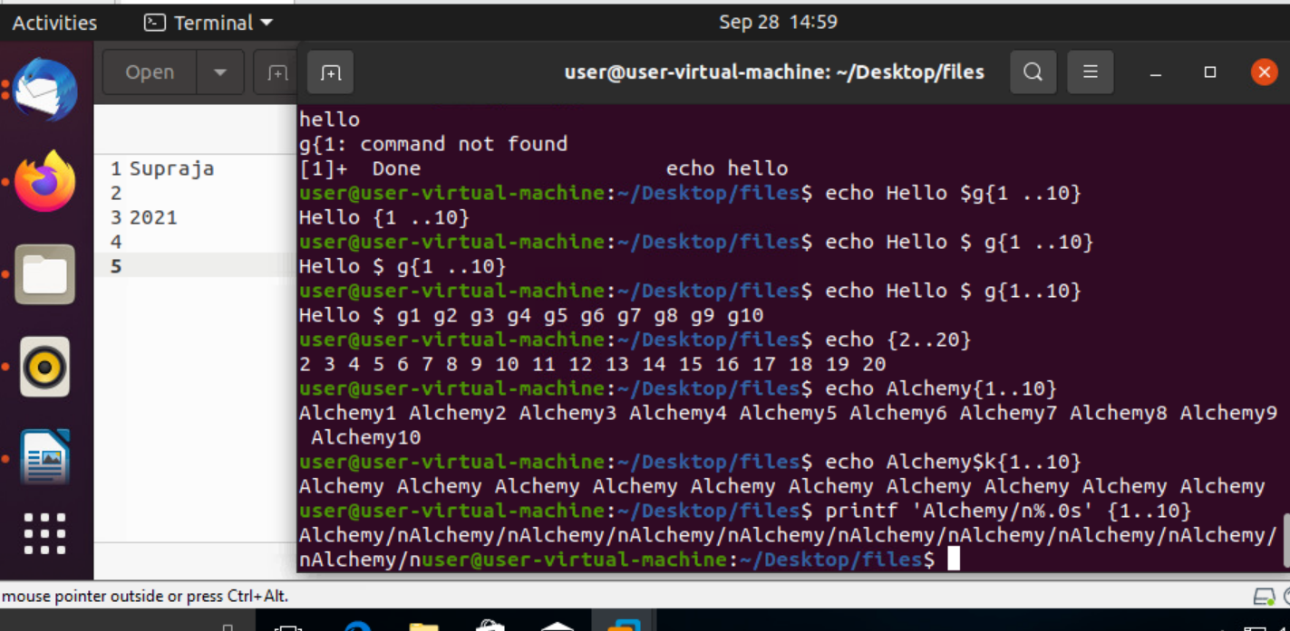

Printf ‘alchemy/n%.0s’ {1..10}: Alchemy/n Alchemy……………..Alchemy/n

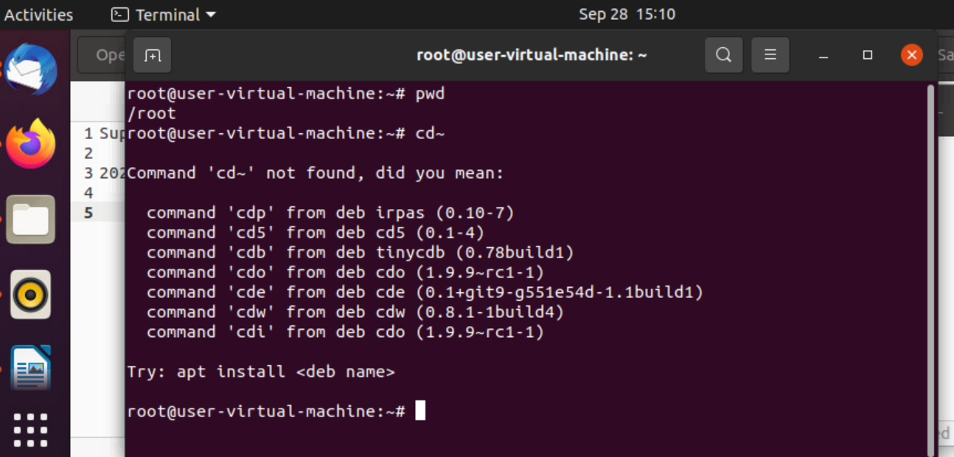

sudo -i: The sudo command allows user to run command with the root power described above

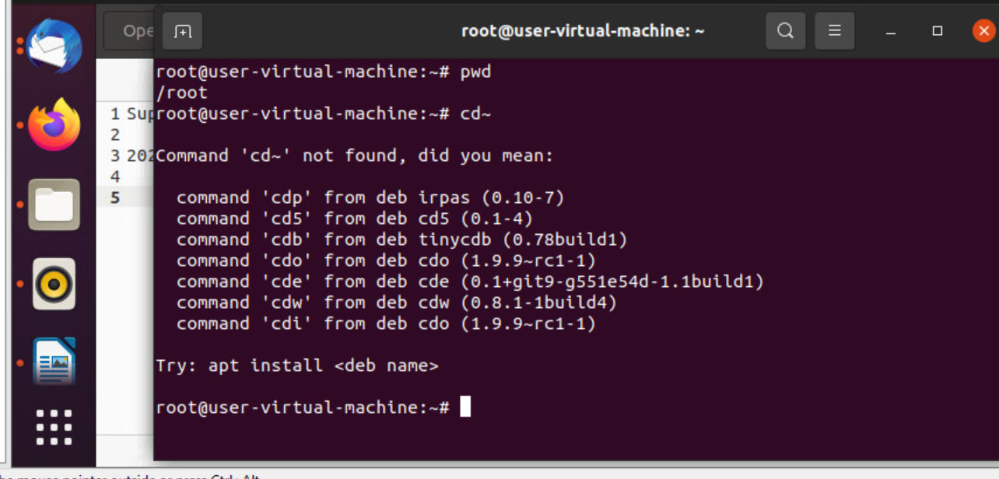

To navigate into the root directory, use "cd /"

To navigate to your home directory, use "cd" or "cd ~"

To navigate up one directory level, use "cd .."

To navigate to the previous directory (or back), use "cd -"

Pwd: pwd stands for Print Working Directory. It prints the path of the working directory,

starting from the root. pwd is shell built-in command(pwd) or an actual binary(/bin/pwd).

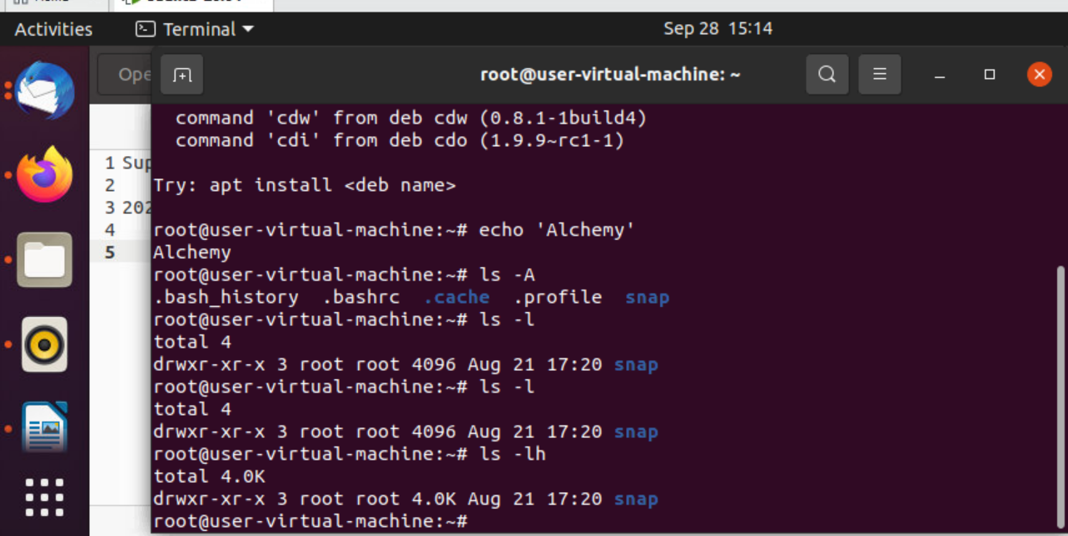

Echo ‘Alchemy’: print Alchemy

Ls -a: It display all file including Hidden file also.

Ls -l: Display list in Long Format

ls -t : It sorts the file by modification time, showing the last edited file first. head -1 picks up this first file.

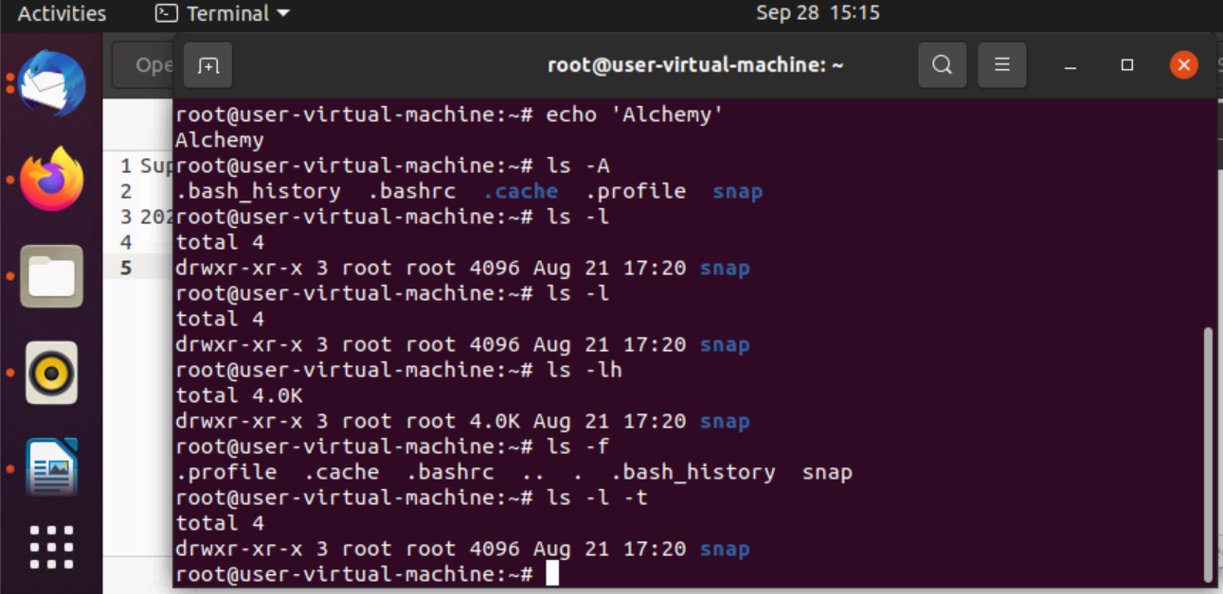

Ls -a: It display all file including Hidden file also.

Ls -l: Display list in Long Format

Ls -f: Display folder without colour.

ls -A: To show the hidden files, but not the ‘.’ (current directory) and ‘..’ (parent directory).

ls -R: Display Files Recursively Using ls -R

ls -lh: Display size in kb.

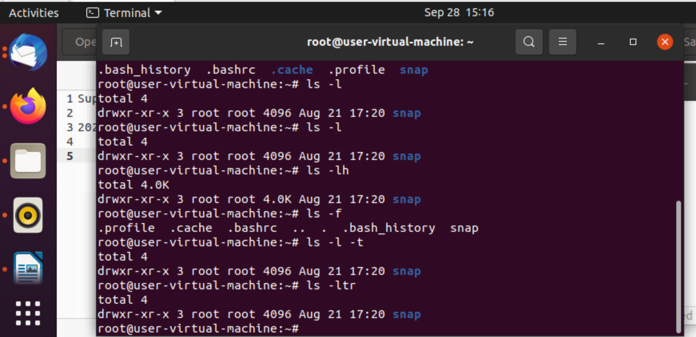

Ls -a: It display all file including Hidden file also.

Ls -l: Display list in Long Format

ls -t: It sorts the file by modification time, showing the last edited file first. head -1 picks up this first file.

Ls -f: Display folder without colour.

ls -A: To show the hidden files, but not the ‘.’ (current directory) and ‘..’ (parent directory).

ls -R: Display Files Recursively Using ls -R

ls -lh: Display size in kb.

ls -ltr /var: It’s worth mentioning that the ls command does not show the total space occupied by the directory contents.